Stateless vs Stateful Systems

🧾 What Are Stateless and Stateful Systems?
# Source: AI Source: Provided by: [Data Path: Persons Table -> ID Column: 1, Name_En Column: Motasem Essam] -> From: [ChatGPT] on [2/12/2026]
These are two ways a system handles user data and memory between requests.
They determine whether the server remembers the user or not.

✅ Simple Definition:
# Source: AI Source: Provided by: [Data Path: Persons Table -> ID Column: 1, Name_En Column: Motasem Essam] -> From: [ChatGPT] on [2/12/2026]
● Stateful System → Server remembers user data (stores state)
● Stateless System → Server does NOT remember anything; each request is independent

🧠 Real-Life Analogy:

🏨 Stateful (Hotel)
# Source: AI Source: Provided by: [Data Path: Persons Table -> ID Column: 1, Name_En Column: Motasem Essam] -> From: [ChatGPT] on [2/12/2026]
● You check in → hotel stores your details
● Staff remembers you
● You don’t repeat your info

🛒 Stateless (Supermarket)
# Source: AI Source: Provided by: [Data Path: Persons Table -> ID Column: 1, Name_En Column: Motasem Essam] -> From: [ChatGPT] on [2/12/2026]
● Every visit → you start fresh
● No memory of previous visits
● You provide all info again

🔁 How Stateful Systems Work
# Source: AI Source: Provided by: [Data Path: Persons Table -> ID Column: 1, Name_En Column: Motasem Essam] -> From: [ChatGPT] on [2/12/2026]
- 👤 User logs in
- 🧠 Server creates a session
- 🔑 Session ID is generated
- 🍪 Stored in browser (cookie)
- 🔁 Each request sends Session ID
- 📦 Server retrieves session data

🔁 How Stateless Systems Work
# Source: AI Source: Provided by: [Data Path: Persons Table -> ID Column: 1, Name_En Column: Motasem Essam] -> From: [ChatGPT] on [2/12/2026]
- 👤 User logs in
- 🔐 Server generates a token (JWT)
- 💾 Token stored on client
- 🔁 Token sent with every request
- ✅ Server verifies token only

💻 Example in PHP

🔹 Stateful (Session)
# Source: AI Source: Provided by: [Data Path: Persons Table -> ID Column: 1, Name_En Column: Motasem Essam] -> From: [ChatGPT] on [2/12/2026]
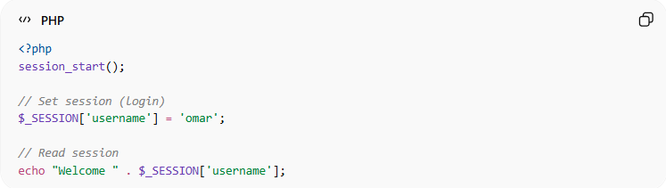
<?php
session_start();

// Set session (login)
$_SESSION['username'] = 'omar';

// Read session
echo "Welcome " . $_SESSION['username'];
● Data is stored on the server
● Session ID is stored in cookie
● Server remembers the user

🔹 Stateless (Token - Simple Example)
# Source: AI Source: Provided by: [Data Path: Persons Table -> ID Column: 1, Name_En Column: Motasem Essam] -> From: [ChatGPT] on [2/12/2026]
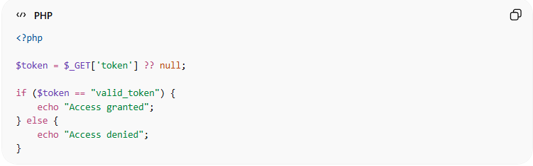
<?php

$token = $_GET['token'] ?? null;

if ($token == "valid_token") {
echo "Access granted";
} else {
echo "Access denied";
}
● No data stored on server
● Each request must include token
● Server only verifies the token

⚔️ Key Differences
# Source: AI Source: Provided by: [Data Path: Persons Table -> ID Column: 1, Name_En Column: Motasem Essam] -> From: [ChatGPT] on [2/12/2026]
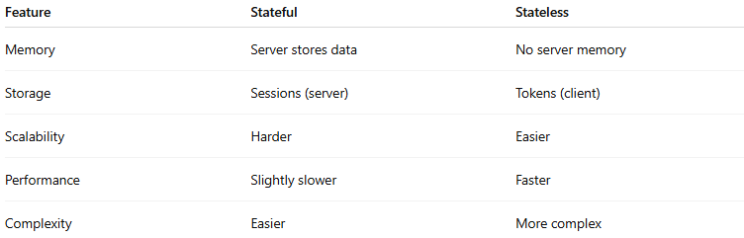
Feature | Stateful | Stateless
Memory | Server stores data | No server memory
Storage | Sessions (server) | Tokens (client)
Scalability | Harder | Easier
Performance | Slightly slower | Faster
Complexity | Easier | More complex

📦 Technologies Used
# Source: AI Source: Provided by: [Data Path: Persons Table -> ID Column: 1, Name_En Column: Motasem Essam] -> From: [ChatGPT] on [2/12/2026]
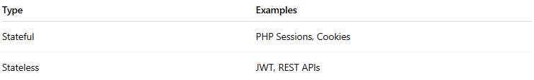
Type | Examples
Stateful | PHP Sessions, Cookies
Stateless | JWT, REST APIs

⚡ Advantages

✅ Stateful
# Source: AI Source: Provided by: [Data Path: Persons Table -> ID Column: 1, Name_En Column: Motasem Essam] -> From: [ChatGPT] on [2/12/2026]
● Simple to implement
● More control over user data
● Good for traditional web apps

✅ Stateless
# Source: AI Source: Provided by: [Data Path: Persons Table -> ID Column: 1, Name_En Column: Motasem Essam] -> From: [ChatGPT] on [2/12/2026]
● Highly scalable
● No server storage needed
● Ideal for APIs & microservices

⚠️ Disadvantages

❌ Stateful
# Source: AI Source: Provided by: [Data Path: Persons Table -> ID Column: 1, Name_En Column: Motasem Essam] -> From: [ChatGPT] on [2/12/2026]
● Uses server memory
● Hard to scale (needs shared sessions)

❌ Stateless
# Source: AI Source: Provided by: [Data Path: Persons Table -> ID Column: 1, Name_En Column: Motasem Essam] -> From: [ChatGPT] on [2/12/2026]
● Harder to implement
● Token security must be handled carefully
● Cannot easily revoke tokens

🛡️ Security Considerations

Stateful
# Source: AI Source: Provided by: [Data Path: Persons Table -> ID Column: 1, Name_En Column: Motasem Essam] -> From: [ChatGPT] on [2/12/2026]
● Protect session ID
● Use HTTPS
● Regenerate session after login

Stateless
# Source: AI Source: Provided by: [Data Path: Persons Table -> ID Column: 1, Name_En Column: Motasem Essam] -> From: [ChatGPT] on [2/12/2026]
● Use short-lived tokens
● Store tokens securely (HttpOnly cookies)
● Validate token signature

🧠 When to Use Each

Use Stateful when:
# Source: AI Source: Provided by: [Data Path: Persons Table -> ID Column: 1, Name_En Column: Motasem Essam] -> From: [ChatGPT] on [2/12/2026]
● Traditional websites
● Server-side apps (PHP, Laravel)
● Need easy session management

Use Stateless when:
# Source: AI Source: Provided by: [Data Path: Persons Table -> ID Column: 1, Name_En Column: Motasem Essam] -> From: [ChatGPT] on [2/12/2026]
● APIs
● Mobile applications
● Microservices
● High scalability systems

🔍 Stateless Session vs Stateful Session (Clear View)

🔹 Stateless Session
# Source: AI Source: Provided by: [Data Path: Persons Table -> ID Column: 1, Name_En Column: Motasem Essam] -> From: [ChatGPT] on [2/12/2026]
● Server does NOT store session data
● Uses tokens (JWT)
● Each request contains all required info

🔹 Stateful Session
# Source: AI Source: Provided by: [Data Path: Persons Table -> ID Column: 1, Name_En Column: Motasem Essam] -> From: [ChatGPT] on [2/12/2026]
● Server stores session data
● Uses Session ID + cookies
● Server remembers the user

🎓 Final Mental Model
# Source: AI Source: Provided by: [Data Path: Persons Table -> ID Column: 1, Name_En Column: Motasem Essam] -> From: [ChatGPT] on [2/12/2026]
👉 Stateful = Server remembers you
👉 Stateless = You prove who you are every time

